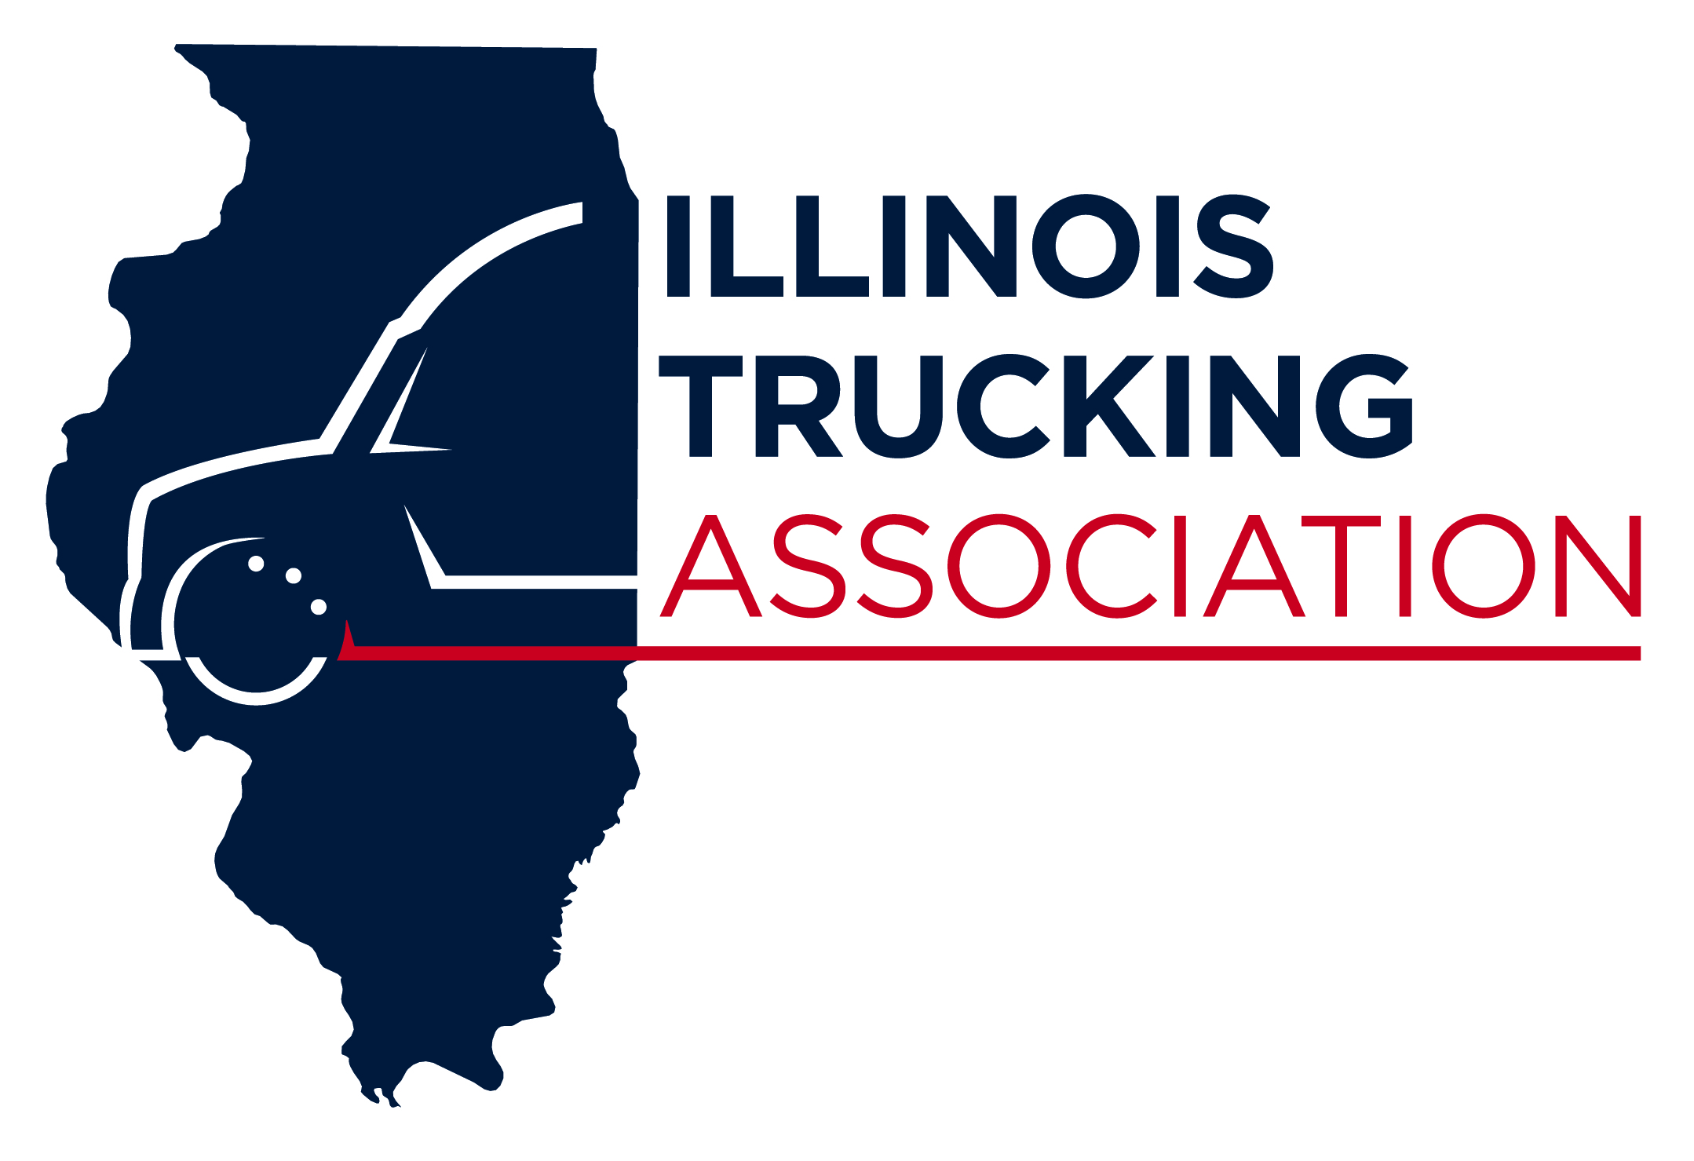

2025 SAFETY MAINTENANCE CONFERENCE
April 8 & 9, 2025 - DoubleTree by Hilton, Bloomington, IL
SPONSORSHIP FORM

The support of our sponsors is crucial to the success of the Safety & Maintenance Conference. The ITA appreciates your support for the Conference. Please consider a Presenting Sponsorship and/or an Event Sponsorship. To be advertised at the Safety and Maintenance Conference as an event sponsor, forms are due by March 15, 2025.

Presenting Sponsorships Available
Presenting sponsors will have their company name & logo continually displayed throughout the Safety & Maintenance Conference. Details of each level can be found on the following page.
$2,500 – Gold Level Sponsor
$1,200 – Silver Level Sponsor
$ 750 – Bronze Level Sponsor

Event Sponsorships Available
$2,000 – Wednesday Safety Awards Banquet
$1,700 – Tuesday Inspiration Lunch Speaker
$2,000 – Tuesday Banquet Speaker Sponsor
$1,800 – Tuesday Cocktail Reception
$ 950 – DJ Cocktail Reception
$1,000 – Tuesday & Wednesday Daytime Beverage Sponsor
$1,500 – Wednesday Breakfast
$1,700 – Wednesday Speaker
$1,000 – Name Badges
$ 700 – Lanyards
$ 600 – Tuesday AM Break
$ 600 – Tuesday PM Break

Name: __________________________________________________ Company: ___________________________________

Address: ___________________________________________ City: ___________________ State: ______ Zip:___________

Email: ___________________________________

Please Select Sponsorship Level:

Presenting Sponsor Level: _____Gold _____Silver _____Bronze

Event Sponsor (please list event(s) to sponsor): ______________________________________________________________

Name of Sponsorship as you would like it to appear: ___________________________________________________________

Payment Information:
□ Check Enclosed □ Visa □ Mastercard □ Discover □ Use payment information on Conference Registration
Card Number:_______________________________________________

Expiration: ____________________ CIV Code: _______

Name on Card: _____________________________________

Billing Address on Card:_________________________City:_________________ State: _______ Zip: ___________

Please return completed form to:
Illinois Trucking Association or Scan & Email to Linda: linda@iltrucking.org
2250 S Chicago St., Suite 201
Joliet, IL 60436
Presenting Sponsor Description

Gold - $3,000
2 Conference Registrations (1000.00 Value)
Vendor Booth
Email Announcement of Gold Sponsorship
ITA Social Media Marketing Announcing Gold Sponsorship
Company Name on all event SMC marketing including ITA Email Newsletters and ITN Magazine
Speaking opportunity at the Awards Banquet
Limited to 3 Companies

Silver - $2,000
1 Conference Registration ($500 Value)
ITA Social Media Marketing Announcing Gold Sponsorship
Company Name on all event SMC marketing including ITA Email Newsletters and ITN Magazine

Bronze - $1,000
ITA Social Media Marketing Announcing Bronze Sponsorship
Company Name on all event SMC marketing including ITA Email Newsletters, ITN Magazine

Thank you for your support of the Illinois Trucking Association.

The ITA is a non-profit organization led by trucking companies to promote and protect the trucking industry in Illinois.

